**Battle Bounce**

**Importing Project & Project Setup**

1. Acquire project from GitHub using the URL (<https://github.com/RajeshChilagani/Joust.git>)
2. Open your Git client (ex: Git Kraken, GitHub Desktop) and clone the repository using above URL.
3. Install any HTML editor of your choice (ex: VS Code, Sublime Text) and open the repository folder in the editor.
4. Now you should be able to see all project files (HTML & JavaScript files).

**File Structure**

Code folder contains all the files required for the game.

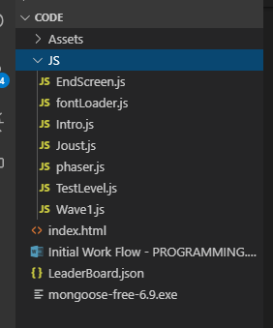

Assets Folder contains all image and audio files used in the game.

JS folder contains all JavaScript files. All new JavaScript files will be added here.

**Phaser.js**

This is the engine JavaScript file that provides features to make a game like physics, collisions, rendering and etc.

**fontLoader.js**

This is used to load google web fonts in the game.

**Joust.js**

It contains all the configurations for the game. Example: The size of the canvas, Physics Type, Scenes, etc.

**Intro.js**

This is the first scene in the game with intro screen and music.

**Wave1.js**

This the second scene in the game where all action takes place.

Following is the code structure

**Wave1 constructor**

It contains all the global variables used in the game.

**Preload**

All the Art & Music assets are loaded here.

**Create**

Game Objects are created here using the assets loaded in the preload function. Animations Colliders, and sounds are also added here.

**Update**

This function is called for every frame in the game. So, all the updates are done here like enemy movement, player movement and other game features.

**PlayAnim**

This function handles all the player animations with player states. It switch’s between 3 different types of fly animations and a run animation based on the player speed and his state.

**SpawnEnemy**

This function handles spawning enemies on platforms randomly.

**EnemyMove**

This function is responsible for the enemy movement in the game.

**eggMove**

This function handles the egg movement which spawns after enemy’s death.

**pterodactylSpawn**

This function handles spawning ghost enemies on platforms randomly.

**pterodactylMove**

This function is responsible for the ghost movement in the game.

**Lives**

This function handles the player lives in the game. It reduces the number of lives and respawns him in the correct position until game is over.

**CheckCollision**

This function checks for the collision between player and enemies and updates score and other game information.

Apart from these there are other callback functions which are self-explanatory.

**EndScreen.js**

This is the final screen where the leaderboard and other game over logic is implemented.

**Index.html**

Index.html is the main html where all the JavaScript’s are imported. It also contains cabin art and few CSS tweaks for canvas.

**Running the Game**

Install any web server application of choice (ex: monogoose) to run the game.